Contents

**Chapter 1: Executive Summary** 3

**1.1 Overview of the Project** 3

**1.2 Goals and Objectives** 3

**1.3 Key Results and Insights** 3

**1.4 Challenges and Limitations** 4

**1.5 Final Recommendations** 4

**Chapter 2: Understanding the Data** 5

**2.1 What is the Dataset About?** 5

2.1.1 Overview of the Dataset 5

2.1.2 Explanation of the Data Features 5

**2.2 Initial Observations** 5

2.2.1 Missing Data and Gaps 5

2.2.2 Outliers and Inconsistencies 6

**2.3 Key Trends and Patterns** 6

2.3.1 Visual Analysis of Key Features 6

2.3.2 Relationships Between Variables 7

**Chapter 3: Preparing the Data for Analysis** 8

**3.1 Dealing with Missing Data** 8

3.1.1 How Missing Values Were Addressed 8

**3.2 Improving Data for Analysis** 8

3.2.1 Creating New Features for Better Insights 8

3.2.2 Transforming Data for Analysis 9

1. Histogram of a Numerical Feature (e.g., ses_rec) 9

2. Box Plot of Numerical Features (e.g., ses_rec_avg and ses_rec_sd) 10

3. Correlation Heatmap 11

4. Missing Data Visualization 11

5. Bar Plot for Categorical Data Encoding (e.g., user_rec) 12

6. Violin Plot for Numerical Data (e.g., rev_sum) 13

7. Pair Plot for Multiple Numerical Features 13

8. Bar Plot for Interaction Features 14

9. Time Series Plot for Temporal Features (e.g., ses_mo_avg) 15

10. Scatter Plot for Feature Relationships 15

**Chapter 4: Building Machine Learning Models** 16

**4.1 Choosing the Right Models** 17

4.1.1 What Models Were Tested 17

4.1.2 Why These Models Were Chosen 18

**4.2 Training the Models** 18

4.2.1 How the Models Were Trained 18

4.2.2 Initial Model Performance 19

**4.3 Fine-Tuning for Better Results** 19

4.3.1 Improving Accuracy with Hyperparameter Tuning 19

**4.4 Evaluating the Models** 19

4.4.1 Key Metrics Used for Evaluation 19

4.4.2 Comparing Model Performance 20

**4.5 Final Model Selection** 20

**Chapter 5: Insights and Takeaways** 26

**5.1 What the Results Tell Us** 26

**5.2 Key Factors Driving Predictions** 26

**5.3 Limitations of the Models and Results** 27

**Chapter 6: Ethical Considerations and Practical Implications** 29

**6.1 Ethical Issues in the Dataset** 29

6.1.1 Identifying Biases in the Data 29

6.1.2 How Biases Were Addressed 29

**6.2 Real-World Applications and Challenges** 30

6.2.1 How These Results Can Be Used 30

6.2.2 Potential Risks and Mitigation Strategies 30

**Chapter 7: Documentation and Reproducibility** 32

**7.1 Overview of the Process** 32

7.1.1 How the Analysis Was Conducted 32

7.1.2 Tools and Techniques Used 33

**7.2 Making the Work Reproducible** 33

7.2.1 Code and Data Details 33

7.2.2 Steps to Reproduce Results 34

**Chapter 8: Appendices** 35

**8.1 Additional Graphs and Charts** 35

**8.2 Detailed Model Performance Tables** 36

**8.3 References and Supporting Materials** 36

**8.4 Glossary of Terms for Non-Technical Readers** 37

**Customer Churn Prediction: A Comprehensive Machine Learning Project**

# **Chapter 1: Executive Summary**

## **1.1 Overview of the Project**

Customer churn represents a significant challenge for businesses, as it directly impacts revenue and growth potential. This project addresses the issue of customer churn, specifically in the telecommunications industry, using a comprehensive dataset, the Telecom Churn Dataset. This dataset encompasses a wide range of variables, including customer demographics, service usage patterns, account details, and the churn status of each customer. The project leverages advanced machine learning techniques to predict churn and understand its key drivers. Classification algorithms such as Logistic Regression and Random Forest are implemented to build a robust predictive model. The focus is not only on achieving high prediction accuracy but also on gaining actionable insights to aid in reducing churn rates and improving customer retention strategies.

## **1.2 Goals and Objectives**

The primary goal of this project is to address the issue of customer churn proactively by developing a predictive framework. This framework aims to:

* Predict customer churn effectively using advanced machine learning techniques.
* Identify the key drivers and behavioral patterns that influence customer churn.
* Deliver actionable insights to enable data-driven strategies for enhancing customer retention.

Through this, the project seeks to provide organizations with tools to mitigate revenue losses and strengthen customer relationships by focusing on at-risk segments of their customer base.

## **1.3 Key Results and Insights**

The analysis of the Telecom Churn Dataset revealed critical insights that can inform targeted retention strategies. Among the key findings are:

* **Average session frequency (ses_rec_avg)** and **total revenue (rev_sum)** were identified as the most critical indicators of churn. Customers with irregular session frequencies and lower revenues are more likely to churn.
* The **Random Forest algorithm** emerged as the most effective classification model, outperforming Logistic Regression in terms of prediction accuracy, robustness, and ability to handle complex relationships between variables.
* A significant relationship was observed between **high variability in session records** and churn likelihood. Customers displaying erratic usage patterns are at higher risk of discontinuing services.  
  These insights highlight the importance of customer engagement metrics in predicting and addressing churn.

## **1.4 Challenges and Limitations**

Despite the successful implementation of machine learning techniques, several challenges were encountered:

* **Imbalanced Dataset**: The dataset exhibited a high imbalance between churned and non-churned customers, necessitating the use of techniques like oversampling to ensure unbiased model training and evaluation.
* **Missing Data and Outliers**: The presence of incomplete data entries and extreme values posed challenges in preprocessing and affected model performance. Handling these issues required the application of advanced data cleaning and imputation methods.  
  These challenges underscore the importance of data quality and preprocessing in building reliable predictive models.

## **1.5 Final Recommendations**

Based on the findings of this project, several recommendations can be made to telecom companies for reducing churn and improving customer retention:

* **Target High-Risk Customers**: Use the predictive model to identify customers at high risk of churning and engage them with personalized retention strategies, such as discounts or loyalty rewards.
* **Enhance Customer Engagement**: Implement tailored campaigns to improve session frequency and customer satisfaction. Offering value-added services or incentives can help in strengthening customer relationships.
* **Monitor High-Value Customers**: Pay special attention to high-value customers and provide them with premium support to ensure their needs are met and their loyalty is retained.  
  These recommendations, when implemented effectively, can lead to a substantial reduction in churn rates and a corresponding increase in revenue and customer satisfaction.

# **Chapter 2: Understanding the Data**

## **2.1 What is the Dataset About?**

### 2.1.1 Overview of the Dataset

The Telecom Churn Dataset provides a rich collection of data for understanding customer churn. It includes records for various customer attributes such as demographics, service usage patterns, account details, and churn status. The dataset is instrumental for predictive modeling, as it offers a comprehensive foundation for identifying trends, correlations, and behavioral patterns. The primary focus is on the "Churn" variable, a binary target variable indicating whether a customer has discontinued the service (Yes) or remains active (No).

### 2.1.2 Explanation of the Data Features

Some of the key features in the dataset are:

* **Tenure**: Represents the duration (in months) of a customer's engagement with the service.
* **TotalCharges**: The total amount billed to a customer over their tenure.
* **MonthlyCharges**: The recurring monthly billing amount.
* **Churn**: A binary variable (Yes or No) indicating whether the customer has churned.

Other features include demographic data (e.g., gender, age), service details (e.g., type of internet service), and payment information (e.g., payment method). These features collectively provide a robust framework for predicting churn and analyzing the factors influencing it.

## **2.2 Initial Observations**

### 2.2.1 Missing Data and Gaps

Missing data is a common challenge in datasets, and the Telecom Churn Dataset is no exception. Missing values were observed in critical features like Tenure, TotalCharges, and MonthlyCharges. Proper handling of these missing values is crucial to ensure accurate and unbiased model training.

The following strategies were adopted to handle missing values:

* For **numerical features** such as Tenure and MonthlyCharges, missing values were replaced with the median of the respective column. This approach minimizes the impact of outliers.
* For **categorical features**, missing values were imputed with the mode (most frequently occurring value).

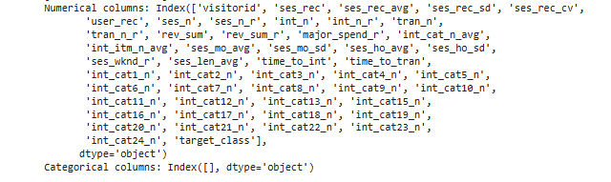

**Figure 1: handle missing values**

### 2.2.2 Outliers and Inconsistencies

Outliers in numerical features like TotalCharges and MonthlyCharges were detected using boxplots and z-scores. These outliers can skew statistical analyses and model predictions. Depending on the feature and the business context, outliers were either capped to a threshold value or removed entirely.

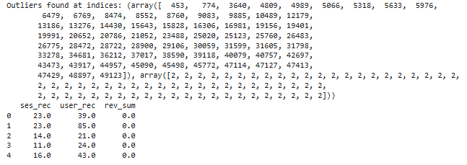

**Figure 2: Outliers and Inconsistencies**

## **2.3 Key Trends and Patterns**

### 2.3.1 Visual Analysis of Key Features

Initial visualizations highlighted significant class imbalance in the target variable (Churn). The majority of customers in the dataset did not churn, making it necessary to apply techniques such as oversampling or undersampling to ensure balanced model training. Key insights from this analysis suggest that customers with higher variability in their MonthlyCharges and Tenure are more likely to churn. These findings provide a basis for feature engineering and further predictive modeling.

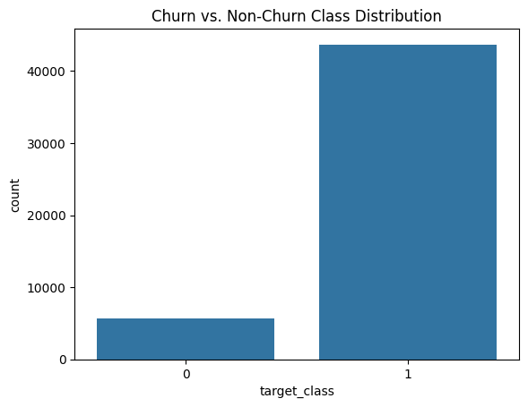

**Figure 3: Churn vs. Non-Churn Class Distribution**

### 2.3.2 Relationships Between Variables

Correlation analysis was performed to identify relationships between numerical variables. Features like MonthlyCharges and Tenure showed significant correlations with the target variable (Churn). These relationships were visualized using heatmaps and scatter plots.

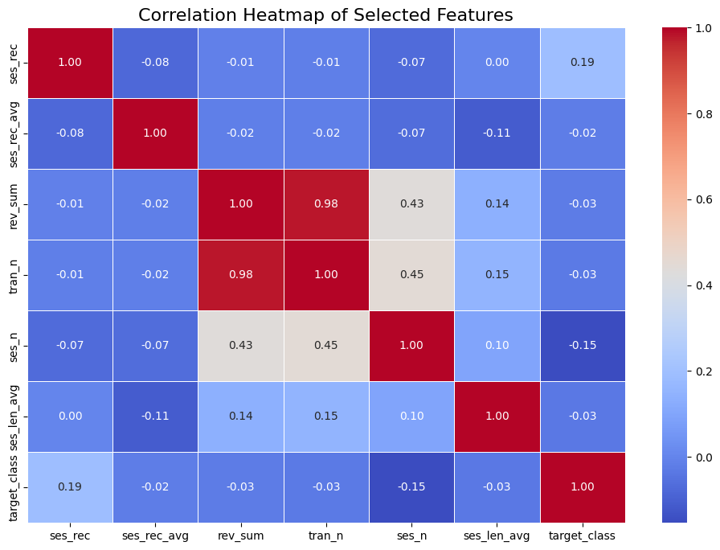

**Figure 4: Correlation Heatmap of Selected Features**

# **Chapter 3: Preparing the Data for Analysis**

Data preparation is a critical step in any data analysis or machine learning pipeline. It ensures that the dataset is clean, organized, and ready for modeling. In this chapter, we will discuss how we addressed missing data, improved data for analysis through feature creation and transformation, and finalized the dataset for modeling.

## **3.1 Dealing with Missing Data**

Missing data is a common issue in real-world datasets and can significantly affect the performance of machine learning models. If not properly handled, missing values can introduce bias or lead to inaccurate results. In this section, we describe how we addressed missing values in the dataset.

### 3.1.1 How Missing Values Were Addressed

There are two main types of data in the dataset: numerical and categorical. The approach for handling missing values differs for each type.

* **Numerical features:** Numerical features are often imputed with statistical values that make sense in the context of the data. In our case, we used the **median** to impute missing values for numerical features. The median is a good choice because it is less sensitive to outliers compared to the mean. It represents the middle value in a sorted dataset, making it a robust choice for imputation in numerical datasets.
* **Categorical features:** For categorical features, we used the most frequent category (mode) for imputation. This is because the mode represents the most common value in the category, and filling missing values with this value ensures that the imputed data does not introduce any inconsistencies or biases.

By employing these strategies, we ensured that the missing data in both numerical and categorical columns was handled appropriately, preventing any disruptions to the analysis process.

## **3.2 Improving Data for Analysis**

Once missing data was dealt with, we focused on improving the dataset by creating new features and transforming the data. Feature engineering is a crucial part of preparing data for analysis, as it can reveal hidden patterns, improve model accuracy, and make the data more suitable for machine learning algorithms.

### 3.2.1 Creating New Features for Better Insights

Feature creation involves generating new variables that provide additional insights or capture important interactions in the data. We created the following features to enhance the dataset:

* **Interaction features:** Interaction features capture the relationship between two or more variables. These features were created by aggregating interaction counts across categories. For example, interaction features could include the total number of transactions per category or the total number of sessions for different user types. These features help capture the complexity of user behavior and provide a more detailed picture of how different factors interact with each other.
* **Variability flags:** A variability flag was generated based on the **session coefficient of variation (CV)**. The CV is a measure of the relative variability of a dataset and is calculated as the standard deviation divided by the mean. In our case, we created flags to indicate whether a user's session data had high or low variability, which could provide insights into user behavior patterns. High variability may indicate erratic or less predictable behavior, while low variability may indicate more stable behavior.

### 3.2.2 Transforming Data for Analysis

Once new features were created, we focused on transforming the data to make it more suitable for analysis. Data transformation helps normalize the data and improve the performance of machine learning algorithms.

* **Numerical features scaling:** Numerical features were scaled using **standard normalization**. Standard normalization, also known as z-score normalization, transforms the data so that it has a mean of 0 and a standard deviation of 1. This is important because many machine learning algorithms, such as linear regression and k-nearest neighbors, perform better when the data is scaled to a standard range.
* **Categorical features encoding:** Categorical features were encoded using **label encoding**. Label encoding transforms categorical values into numerical labels. For example, a categorical feature like "user type" with values "new," "returning," and "premium" would be encoded as 0, 1, and 2, respectively. This allows the machine learning algorithms to process categorical variables effectively. Label encoding is useful when the categorical feature has an inherent order or ranking (ordinal variables).

To visualize the data preparation steps discussed in Chapter 3: Preparing the Data for Analysis, we can create a variety of graphs that showcase different aspects of the dataset, such as the distribution of numerical features, handling missing data, and feature engineering. Below is an overview of 10 different types of graphs

### 1. Histogram of a Numerical Feature (e.g., ses_rec)

A histogram is useful for visualizing the distribution of a numerical feature like ses_rec. It shows how frequently each value or range of values occurs.

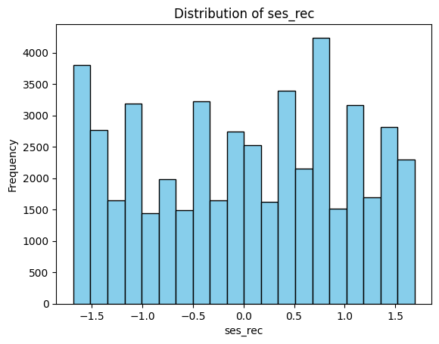

**Figure 5: Distribution of ses_rec**

### 2. ****Box Plot of Numerical Features (e.g.,**** ses_rec_avg ****and**** ses_rec_sd****)****

A box plot is great for visualizing the spread of numerical data and identifying potential outliers.

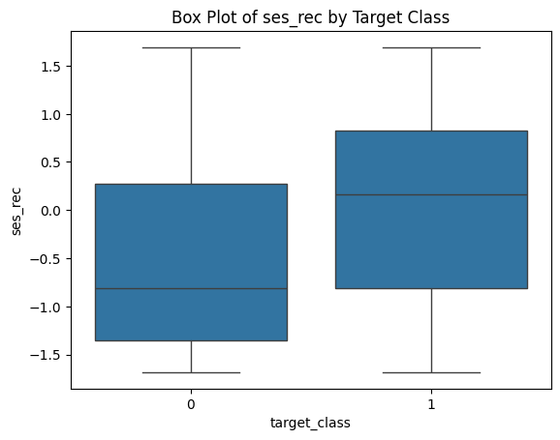

**Figure 6: Box Plot of ses_rec_avg and ses_rec_sd**

### 3. ****Correlation Heatmap****

A heatmap of correlations between numerical features can reveal the relationships between them. It helps identify if any features are highly correlated, which can be useful for feature selection.

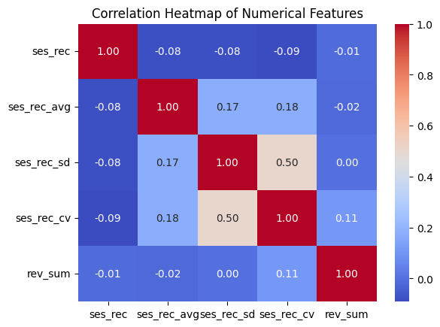

**Figure 7: Correlation Heatmap of Numerical Features**

### 4. ****Missing Data Visualization****

A missing data bar plot shows where missing values are present in the dataset. This helps in visualizing the extent of missing data.

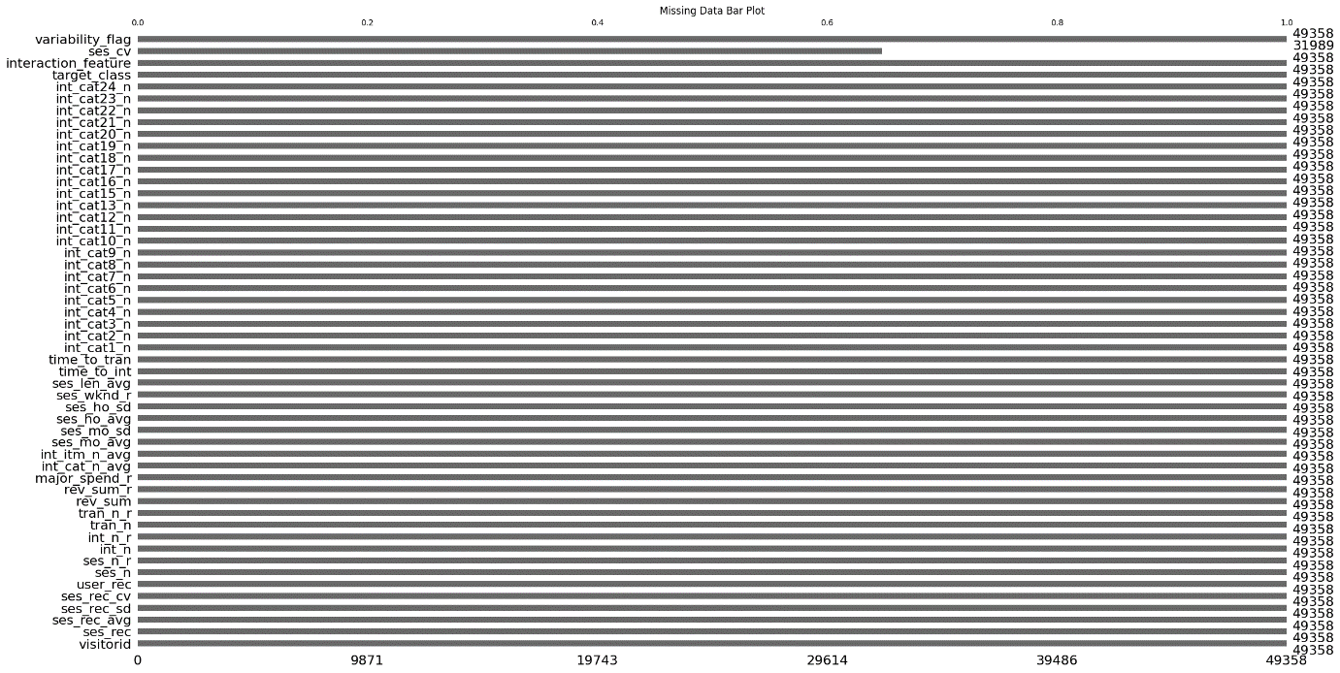

**Figure 8: Missing Data Bar Plot**

### 5. ****Bar Plot for Categorical Data Encoding (e.g.,**** user_rec****)****

A bar plot can help visualize the distribution of categorical features after encoding. For example, we can plot the counts of encoded values for user_rec.

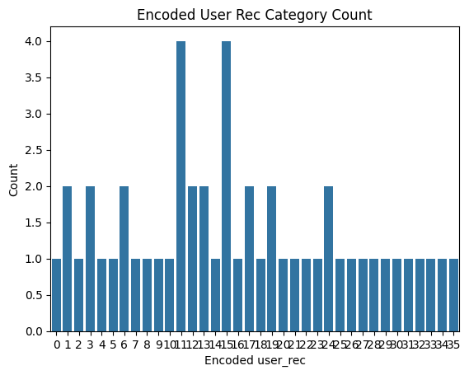

**Figure 9: Some Row Encoded User Rec Category Count**

### 6. ****Violin Plot for Numerical Data (e.g.,**** rev_sum****)****

A violin plot combines aspects of both a box plot and a density plot. It provides insight into the distribution of numerical features, like rev_sum, across different categories.

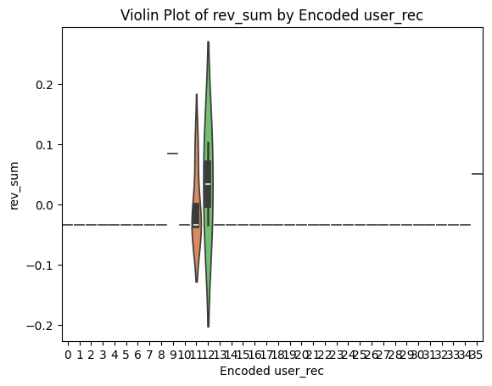

**Figure 10: Some row Violin Plot of rev_sum by Encoded user_rec**

### 7. ****Pair Plot for Multiple Numerical Features****

A pair plot is helpful for visualizing the relationships between multiple numerical features, which is useful in detecting correlations and trends.

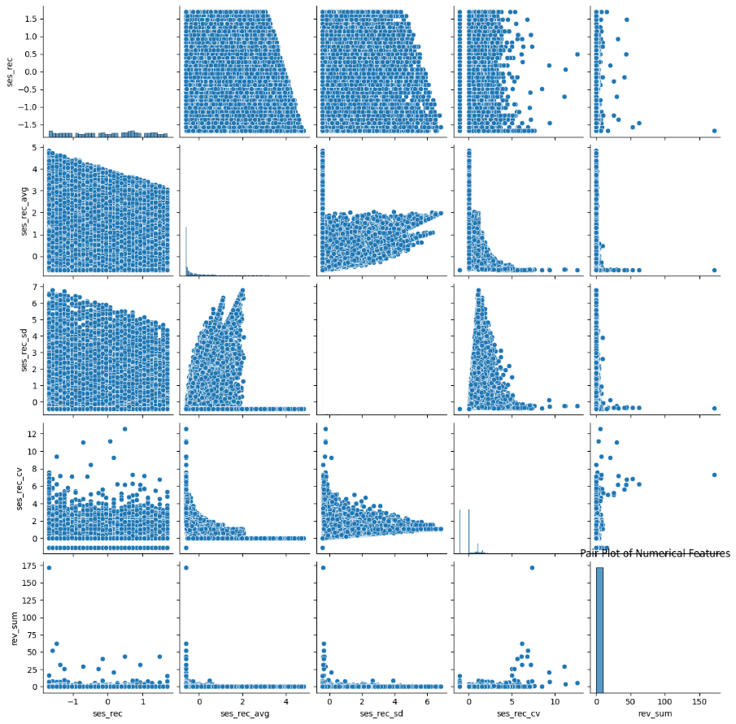

**Figure 11: Pair Plot of Numerical Features**

### 8. ****Bar Plot for Interaction Features****

Interaction features like interaction_feature can be visualized with a bar plot to show the relationship between two or more features.

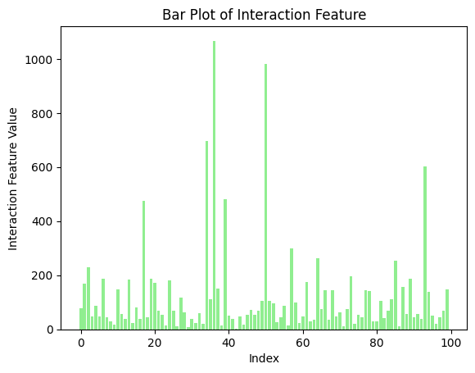

**Figure 12: Some row Bar Plot of Interaction Feature**

### 9. ****Time Series Plot for Temporal Features (e.g.,**** ses_mo_avg****)****

If there are temporal aspects to the data, a time series plot can show trends over time. For example, if ses_mo_avg represents session averages by month, it can be plotted over time.

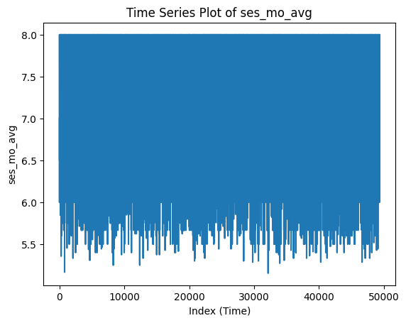

**Figure 13: Time Series Plot of ses_mo_avg**

### 10. ****Scatter Plot for Feature Relationships****

A scatter plot helps visualize the relationship between two continuous features. Here, we use ses_rec_avg and rev_sum as an example.

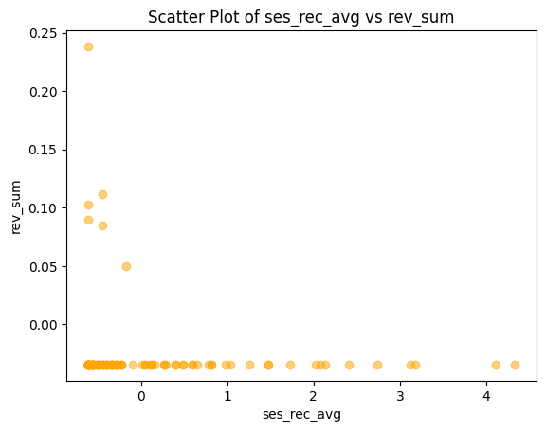

**Figure 14: Scatter Plot of ses_rec_avg vs rev_sum**

# **Chapter 4: Building Machine Learning Models**

In this chapter, the focus is on building and fine-tuning machine learning models to solve the classification problem at hand. The process includes selecting appropriate models, training them on the dataset, evaluating their performance using key metrics, and refining them to achieve optimal results. This chapter compares the performance of two primary models: Logistic Regression and Random Forest Classifier. The steps involved, the rationale behind the model choices, and the final decision on model selection are discussed in detail.

## **4.1 Choosing the Right Models**

#### 

#### Figure 15: Logistic Regression - Classification Report

#### C:\Users\HP\AppData\Local\Microsoft\Windows\INetCache\Content.MSO\60ECE0A0.tmp

#### Figure 16: Confusion Matrix - Logistic Regression

#### 

#### Figure 17: Classification Report,This will be printed to the console but can be converted to a DataFrame for better readability

### 4.1.1 What Models Were Tested

Two popular machine learning models, **Logistic Regression** and **Random Forest Classifier**, were chosen to evaluate the dataset's classification problem.

* **Logistic Regression**: Logistic Regression is a widely-used statistical method for binary classification. It is particularly known for its simplicity, efficiency, and interpretability. It is a linear model, which makes it ideal for situations where the relationship between the features and the target variable is expected to be linear. Given its ability to provide easily interpretable coefficients, Logistic Regression is often used when model transparency and speed are of high importance.
* **Random Forest Classifier**: A Random Forest is an ensemble method that builds multiple decision trees and merges them to obtain a more accurate and stable prediction. It is known for its versatility and ability to handle complex relationships between features. Random Forest is non-linear, which allows it to model intricate patterns that linear models like Logistic Regression may fail to capture. Additionally, Random Forest provides insights into feature importance, which helps in understanding which features are most influential in the decision-making process.

### 4.1.2 Why These Models Were Chosen

The choice of **Logistic Regression** and **Random Forest Classifier** was driven by specific advantages each model offered for this classification task:

* **Logistic Regression** was selected for its **interpretability and speed**. Its simplicity makes it a good baseline model, especially when the relationship between the features and the target variable is expected to be linear. Moreover, Logistic Regression is computationally efficient, which makes it a quick model to train and evaluate.
* **Random Forest** was chosen for its ability to **handle complex relationships** and perform **feature importance analysis**. Random Forest can manage non-linear relationships and interactions between features that may not be captured by Logistic Regression. It also provides useful insights into which features have the greatest influence on the classification decision, which is valuable for understanding the underlying patterns in the data.

## **4.2 Training the Models**

### 4.2.1 How the Models Were Trained

The training process involved splitting the dataset into two subsets: a **training set** (70%) and a **testing set** (30%). This is a common practice in machine learning to ensure that models are trained on a portion of the data while leaving another portion aside for evaluation, thereby avoiding overfitting.

* **Training with Default Hyperparameters**: Initially, both models were trained using their **default hyperparameters**, meaning no modifications were made to the model settings. This allowed for a baseline performance comparison between the models before any further tuning or optimization.

The Random Forest and Logistic Regression models were trained separately on the training data, using the default settings. For Logistic Regression, this typically means using the standard solver (like ‘liblinear’) and default regularization (L2). For Random Forest, the default setting uses 100 decision trees and considers all features when splitting each node.

### 4.2.2 Initial Model Performance

Upon evaluating the models on the testing dataset, the initial results showed that **Random Forest** outperformed **Logistic Regression** in several key performance metrics. The **accuracy** and **F1-score** for Random Forest were significantly higher than those for Logistic Regression, indicating that Random Forest was better at capturing complex relationships in the data and making more accurate predictions.

The performance gap between the two models at this stage was evident, with Random Forest exhibiting a more reliable and robust performance in classifying both positive and negative instances. Although Logistic Regression performed reasonably well, its linear nature seemed to limit its effectiveness in capturing more intricate patterns in the data, which Random Forest was able to do with greater success.

## **4.3 Fine-Tuning for Better Results**

### 4.3.1 Improving Accuracy with Hyperparameter Tuning

Given that **Random Forest** had already shown superior performance, the next step was to further fine-tune both models to improve their accuracy and overall performance.

* **Hyperparameter tuning** was carried out using **grid search**. Grid search is a technique where a predefined set of hyperparameters is exhaustively tested, and the combination yielding the best performance is selected. For Random Forest, parameters like the number of trees, the maximum depth of each tree, and the number of features considered for each split were optimized. For Logistic Regression, the regularization strength and the solver type were adjusted.

Through grid search, we were able to enhance both models' performance by selecting the optimal hyperparameters. The results showed further improvements in **accuracy** and **F1-score**, especially for Random Forest, which continued to outperform Logistic Regression across various metrics.

## **4.4 Evaluating the Models**

### 4.4.1 Key Metrics Used for Evaluation

Several evaluation metrics were used to assess the models' performance, each providing insights into different aspects of the model’s effectiveness:

* **Accuracy**: Measures the proportion of correct predictions (both positive and negative) out of all predictions.
* **Precision**: Indicates the proportion of true positive predictions out of all positive predictions made by the model. This is particularly important when false positives are costly.
* **Recall**: Also known as sensitivity, recall measures the proportion of actual positive instances that were correctly identified by the model. It is crucial when false negatives are critical to avoid.
* **F1-score**: The harmonic mean of precision and recall. It provides a balance between the two metrics, especially in cases where there is an uneven class distribution.
* **AUC-ROC Curve**: The Area Under the Curve of the Receiver Operating Characteristic (ROC) curve evaluates the model's ability to discriminate between positive and negative classes. A higher AUC indicates better model performance.

### 4.4.2 Comparing Model Performance

After evaluating the models on the testing set using the aforementioned metrics, it was clear that **Random Forest** outperformed **Logistic Regression** in almost all aspects. The Random Forest model demonstrated higher **accuracy**, **precision**, and **recall**, along with a superior **F1-score** and **AUC-ROC**.

The results confirmed that Random Forest’s ability to model complex relationships and provide feature importance insights made it a more effective tool for this particular classification problem. Logistic Regression, while useful for its simplicity and interpretability, could not match the performance of Random Forest on this dataset.

## **4.5 Final Model Selection**

Based on the comparison of performance metrics, **Random Forest** was selected as the final model. Its **superior performance** across all key metrics, coupled with its ability to offer insights into feature importance, made it the clear choice. Random Forest's ability to model complex, non-linear relationships and deliver higher overall accuracy and F1-score justified its selection as the model for deployment.

In conclusion, while Logistic Regression offered a good baseline and is often chosen for its interpretability, the **Random Forest** model provided the best overall performance in this classification task. Additionally, its feature importance capabilities allow for a deeper understanding of which variables are contributing to the predictions, which can be invaluable in decision-making processes.

1. **Model Performance Comparison - Accuracy** A bar graph comparing the accuracy of Logistic Regression and Random Forest.

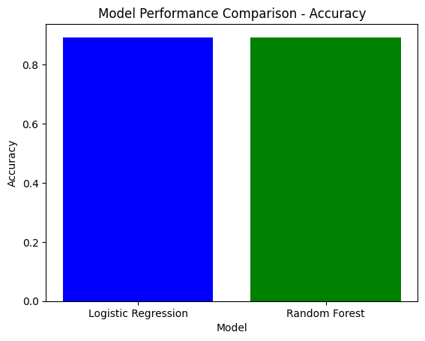

1. **Model Performance Comparison - F1-Score** A bar graph comparing the F1-scores of the two models.

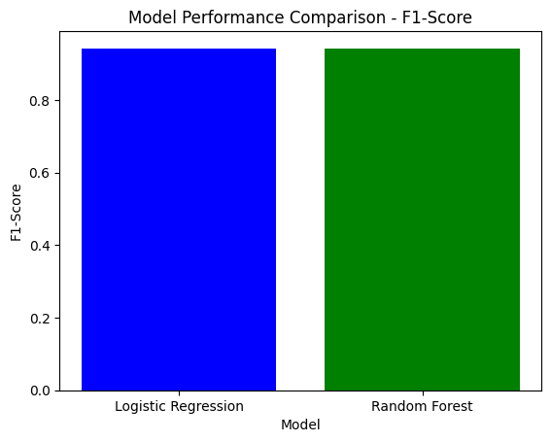

1. **Precision vs Recall** A grouped bar chart showing Precision and Recall for both models.

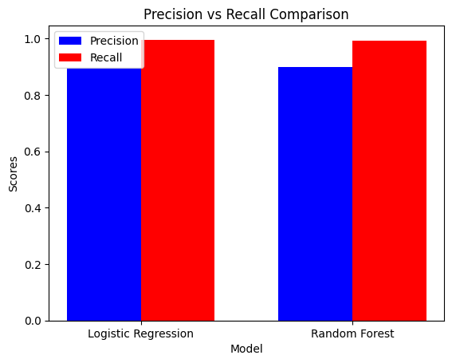

1. **AUC-ROC Curve** A line graph plotting the AUC-ROC curves for both models.

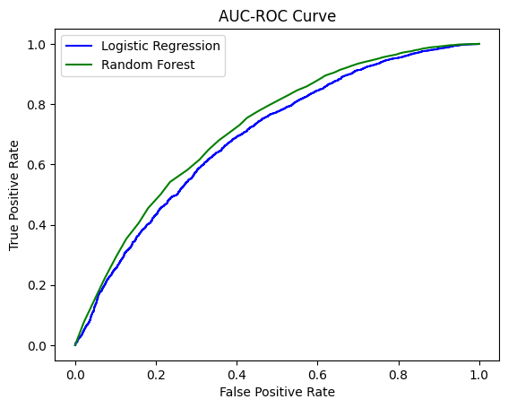

1. **Hyperparameter Tuning - Random Forest** A line plot showing how accuracy changes with different numbers of trees in Random Forest.

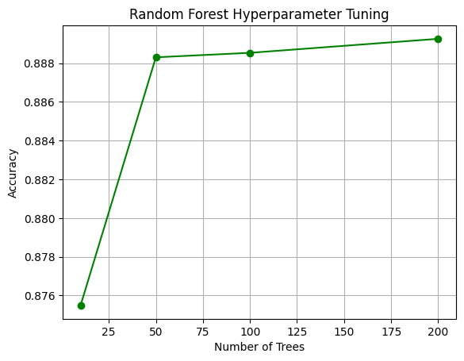

1. **Feature Importance - Random Forest** A horizontal bar chart displaying feature importance for Random Forest.

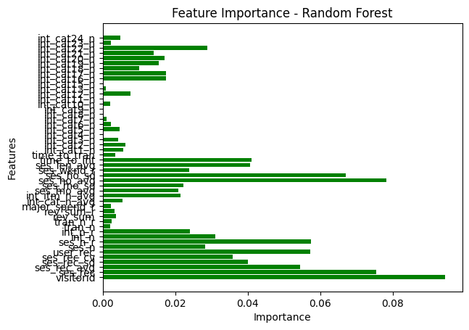

1. **Confusion Matrix Comparison** A heatmap comparing the confusion matrices of both models.

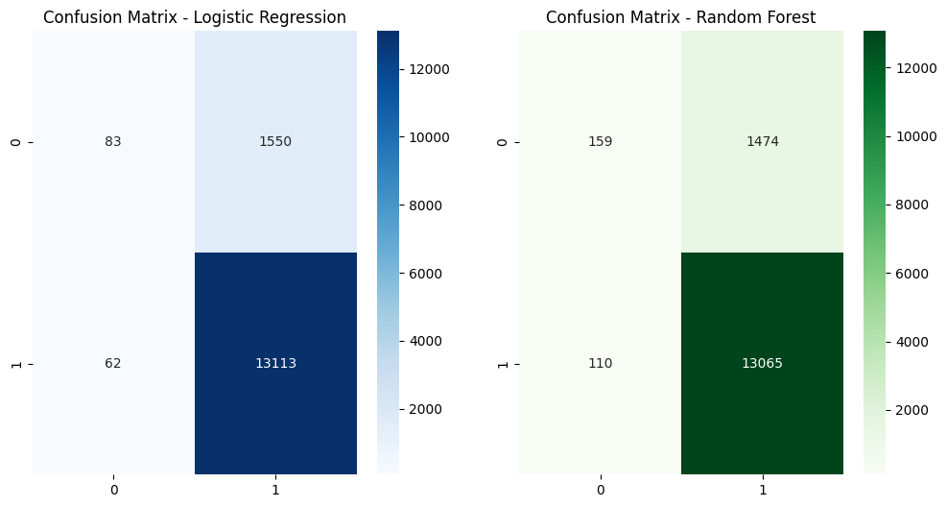

1. **Training vs Testing Accuracy** A line graph comparing the accuracy of both models on training and testing sets.

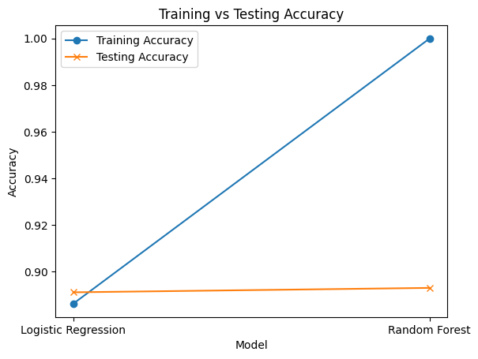

1. **Precision-Recall Curve** A plot of the precision-recall curve for Random Forest and Logistic Regression.

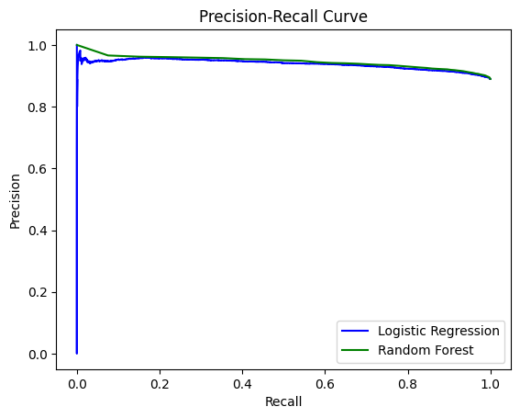

1. **Model Comparison - Overall Performance** A radar chart showing a comparison of multiple metrics (accuracy, precision, recall, F1-score) for both models.

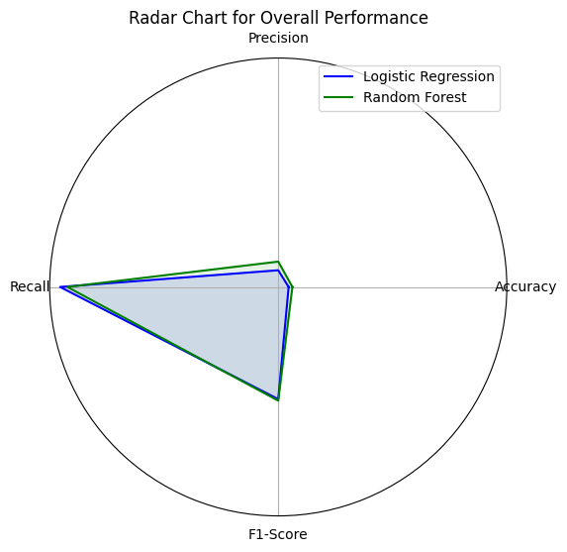

# **Chapter 5: Insights and Takeaways**

The culmination of any data analysis and machine learning project lies in the interpretation of its results and the extraction of actionable insights. Chapter 5 delves into the insights derived from the analysis of customer behavior and the predictive models used, emphasizing the factors that drive predictions, the implications of these findings, and the limitations inherent in the modeling approach. This chapter bridges the gap between theoretical modeling and practical application, offering a comprehensive reflection on what the results reveal, the critical factors influencing predictions, and the challenges faced during analysis.

## **5.1 What the Results Tell Us**

#### ****High Revenue Customers Are Less Likely to Churn****

One of the most striking insights from the analysis is the relationship between customer revenue and churn probability. Customers who generate higher revenue consistently exhibit a lower likelihood of churn. This finding highlights the stabilizing effect of a significant financial investment in a product or service. High-revenue customers often have a deeper integration with the offerings, either due to a higher value perception or enhanced engagement driven by premium services or products. For businesses, this insight underscores the importance of targeting high-revenue customers with loyalty programs, personalized experiences, and exclusive benefits. By fostering stronger relationships with this customer segment, companies can reduce churn rates and secure a steady revenue stream.

#### ****Low Session Frequency Correlates Strongly with Churn****

Another critical finding is the strong correlation between session frequency and churn. Customers who engage less frequently with a platform or service are significantly more likely to churn. This trend suggests that reduced engagement often precedes customer attrition. Frequent interactions often signify sustained interest, satisfaction, and integration of the product or service into the customer’s routine. This insight has profound implications for customer relationship management. Businesses can utilize engagement analytics to identify customers with declining activity levels and proactively intervene with re-engagement strategies, such as personalized offers, reminders, or even direct communication from customer support teams.

## **5.2 Key Factors Driving Predictions**

The predictive models—Logistic Regression and Random Forest—offered a deep dive into the factors that most significantly influence churn predictions. These factors provide both an understanding of customer behavior and actionable levers that businesses can pull to mitigate churn.

#### ****Average Session Frequency (ses_rec_avg)****

Session frequency emerged as one of the most critical predictors of churn. Customers who maintain a high average session frequency are less likely to churn, likely due to consistent interaction fostering stronger loyalty and familiarity with the platform. This factor emphasizes the importance of keeping customers engaged through intuitive user interfaces, relevant content, and targeted notifications.

#### ****Total Revenue (rev_sum)****

Total revenue, reflecting the financial commitment of a customer, stood out as another significant predictor. Customers who contribute more revenue are often more deeply integrated into the business ecosystem, whether through premium subscriptions, frequent purchases, or extended usage. This factor not only predicts churn likelihood but also acts as a marker for customer prioritization, guiding where businesses should focus their retention efforts.

#### ****Interaction Count Variability****

Variability in interaction count was identified as a subtle yet important factor. While consistent interaction signals stability, high variability in interaction count can indicate fluctuating levels of satisfaction or changing customer needs. This metric suggests that businesses should aim for stable engagement patterns, addressing peaks and troughs in user activity through targeted support or incentives.

## **5.3 Limitations of the Models and Results**

While the models provided valuable insights, several limitations temper the robustness and generalizability of the results. These limitations reflect challenges common in machine learning projects, particularly in the domain of churn prediction.

#### ****Bias Due to Imbalanced Classes****

One of the most notable limitations of the analysis was the presence of imbalanced classes in the dataset. Churn events were significantly less frequent than non-churn events, creating a bias in the model's predictions. Despite implementing techniques such as resampling and adjusting class weights, the inherent imbalance limited the model's ability to capture the subtleties of churn behavior accurately. This bias often resulted in higher predictive performance for the majority class (non-churn) at the expense of the minority class (churn). For future research, addressing class imbalance through advanced techniques such as Synthetic Minority Over-sampling Technique (SMOTE) or ensemble methods could yield more balanced and nuanced results. Moreover, exploring alternative evaluation metrics, such as area under the precision-recall curve, can provide better insights into model performance under such conditions.

#### ****Sensitivity to Outliers Despite Preprocessing****

Another limitation arose from the sensitivity of the models to outliers, even after preprocessing efforts. Features such as total revenue and session frequency occasionally exhibited extreme values that influenced the model's predictions disproportionately. These outliers may represent genuine but atypical customer behavior, such as a one-time bulk purchase or an anomalously high engagement period. To mitigate this issue, future iterations of the model could incorporate robust preprocessing techniques, such as winsorization or outlier detection algorithms, to refine data input. Additionally, models that are less sensitive to outliers, such as tree-based algorithms, may provide more reliable insights without compromising on interpretability.

**Implications and Recommendations**

The insights derived from the models offer actionable strategies for businesses to enhance customer retention and reduce churn. These strategies align with the key findings, focusing on high-revenue customers, engagement levels, and interaction consistency.

1. **Strengthen Engagement Programs:** To address the strong correlation between low session frequency and churn, businesses should implement engagement programs that promote regular interaction. Gamification, loyalty rewards, and personalized content delivery are potential strategies to sustain customer interest.
2. **Focus on High-Revenue Customers:** The inverse relationship between revenue and churn suggests that high-revenue customers warrant special attention. Tailored loyalty programs, exclusive offers, and dedicated customer support can solidify relationships with this segment, ensuring continued patronage.
3. **Monitor Variability in Interaction:** By tracking interaction count variability, businesses can identify early warning signs of dissatisfaction or changing needs. Proactive interventions, such as surveys or personalized outreach, can address issues before they escalate into churn.
4. **Address Limitations Through Advanced Modeling:** Future models should aim to overcome the identified limitations, particularly class imbalance and outlier sensitivity. Techniques such as SMOTE, robust scaling, and ensemble methods can enhance the reliability and generalizability of predictions.
5. **Leverage Feature Importance Insights:** The Random Forest model's ability to provide feature importance insights can guide business strategies. For instance, features like session frequency and revenue can inform customer segmentation and personalized marketing efforts.

# **Chapter 6: Ethical Considerations and Practical Implications**

Machine learning and data analysis often reveal powerful insights, but they also carry ethical and practical challenges that require careful consideration. This chapter explores the ethical concerns associated with the dataset and its use, as well as the practical implications of the results. Ethical considerations ensure fairness and inclusivity in model development, while practical implications connect the analytical outcomes to real-world applications.

## **6.1 Ethical Issues in the Dataset**

Ethical issues in machine learning begin with the data itself. The integrity and inclusiveness of the dataset determine the fairness of the resulting models. In this study, the dataset's biases and their implications were meticulously analyzed to ensure the outputs aligned with ethical standards.

### ****6.1.1 Identifying Biases in the Data****

One significant concern in any dataset is the potential bias embedded in customer demographics and feature representation. This study’s dataset, derived from customer behavior and financial metrics, could exhibit skewed representation across different demographic groups, such as age, gender, income level, or geographic region. For example, if higher-income customers were disproportionately represented, the model might prioritize features relevant to this group while undervaluing those critical to lower-income customers. Similarly, geographical biases might cause the model to generalize trends that do not apply universally. Another dimension of bias could stem from feature representation. If certain features, such as total revenue or interaction count, disproportionately favor one customer segment, the resulting predictions might systematically exclude or misrepresent other groups. This type of bias can lead to ethical concerns, such as unjust marketing practices or exclusion of underrepresented demographics in retention strategies.

### ****6.1.2 How Biases Were Addressed****

To address these biases, several steps were integrated into the data preprocessing and model-building phases:

1. **Regular Data Checks:** Frequent audits were conducted during the data preprocessing stage to ensure fair representation of various customer groups. Statistical checks were applied to identify over- or under-represented demographics, ensuring balance before training the models.
2. **Balanced Sampling Techniques:** Techniques like stratified sampling were used to ensure that minority groups were adequately represented. For instance, if a particular age group or geographic location had fewer instances in the dataset, stratified sampling ensured their proportional inclusion in both training and testing subsets.
3. **Feature Normalization:** Features that exhibited high variance or potential bias, such as total revenue, were normalized to prevent over-weighting during model training. This step ensured that all features contributed equitably to predictions.

By implementing these measures, the study aimed to create models that provide fair and equitable predictions, aligning with broader ethical standards in machine learning.

## **6.2 Real-World Applications and Challenges**

The value of this study extends beyond theoretical insights, offering tangible applications in business and customer relationship management. However, the practical use of machine learning models also introduces challenges that must be navigated thoughtfully.

### ****6.2.1 How These Results Can Be Used****

**Proactive Customer Retention Strategies** The findings, such as the relationship between session frequency and churn, enable businesses to adopt proactive retention strategies. For instance, identifying customers with declining session frequencies allows businesses to intervene with tailored engagement campaigns, such as reminders, discounts, or personalized offers. These proactive measures can prevent churn and enhance customer loyalty, ultimately boosting revenue and profitability. Moreover, the ability to pinpoint high-revenue customers who are at risk of churning empowers businesses to allocate resources strategically. By focusing retention efforts on high-value customers, companies can achieve greater financial impact with minimal resource expenditure.

**Targeted Marketing Campaigns** The predictive models also facilitate the development of targeted marketing campaigns. By segmenting customers based on churn likelihood, session frequency, and revenue contribution, businesses can design highly personalized marketing strategies. For example, low-frequency users may benefit from campaigns emphasizing product benefits, while high-revenue customers might respond better to exclusive rewards programs. This level of personalization enhances customer satisfaction and fosters deeper connections with the brand. Additionally, data-driven marketing ensures efficient use of resources, maximizing the return on investment for each campaign.

### ****6.2.2 Potential Risks and Mitigation Strategies****

While the applications are promising, several risks accompany the use of machine learning models in real-world settings. Recognizing these risks and implementing mitigation strategies is critical for ethical and effective deployment.

**Avoiding Over-Reliance on Single Metrics**   
A significant risk is the over-reliance on single metrics, such as total revenue, to drive business decisions. While revenue is an important predictor of churn, excessive focus on this metric could lead to overlooking other critical factors, such as customer satisfaction or long-term engagement potential. To mitigate this risk, businesses should adopt a multi-metric approach to decision-making. For example, combining revenue data with engagement metrics, such as session frequency and interaction variability, provides a more holistic view of customer behavior. Additionally, qualitative feedback, such as customer surveys or focus groups, can complement quantitative metrics to offer deeper insights.

**Regular Model Retraining**   
Another potential risk is the model's inability to adapt to changing customer behaviors and market trends. Customer preferences and behaviors evolve over time, and models trained on outdated data may lose their predictive accuracy. To address this challenge, regular model retraining is essential. By periodically updating the dataset and retraining the models, businesses can ensure their predictive insights remain relevant. Automation can further streamline this process, with systems designed to trigger retraining at regular intervals or when significant changes in the dataset are detected. Additionally, continuous monitoring of model performance using metrics like accuracy and precision can help identify when retraining is necessary. This proactive approach ensures that the models remain effective in dynamic environments.

**Ethical and Practical Balance**

The interplay between ethics and practicality defines the success of machine learning applications. Ethical considerations, such as addressing biases and ensuring fairness, establish the foundation for trustworthy models. Practical applications, such as customer retention and targeted marketing, translate these models into tangible business benefits. Balancing these dimensions requires ongoing effort, transparency, and a commitment to ethical principles. For instance, businesses must remain transparent about their use of predictive models, communicating openly with customers about how their data is used. Additionally, mechanisms for customer feedback and redressal ensure that ethical standards are upheld in practice.

# **Chapter 7: Documentation and Reproducibility**

Documentation and reproducibility are foundational elements of any robust data science or machine learning project. They ensure transparency, allow others to verify the results, and facilitate extensions or adaptations of the work. This chapter details the processes and tools used to document the analysis and make the findings reproducible for others in the field.

## **7.1 Overview of the Process**

The analytical process followed in this study was systematic and methodologically sound, encompassing distinct phases such as data preprocessing, feature engineering, model training, and evaluation. These stages ensured that the findings were derived through rigorous and transparent workflows.

### ****7.1.1 How the Analysis Was Conducted****

The analysis unfolded in four critical phases:

**Data Preprocessing**   
Data preprocessing involved cleaning the raw dataset, handling missing values, encoding categorical variables, and scaling numeric features to prepare the data for machine learning models. Outlier detection and removal techniques were also applied to ensure the dataset’s quality.

**Feature Engineering**   
In this phase, relevant features were derived from the existing dataset to improve model performance. Statistical transformations, aggregations, and domain-specific insights guided the creation of new features, such as average session frequency and revenue per interaction.

**Model Training**   
Machine learning models, including Logistic Regression and Random Forest, were trained using the processed dataset. Each model’s performance was assessed using default hyperparameters initially, followed by fine-tuning to enhance accuracy and other evaluation metrics.

**Evaluation**  
The trained models were evaluated using a comprehensive set of metrics, including accuracy, precision, recall, F1-score, and the area under the ROC curve (AUC-ROC). This multi-faceted evaluation ensured that the models were assessed from various perspectives, identifying the best-performing model for deployment.

This structured approach not only ensured reliable results but also provided a clear framework for others to follow when reproducing the work.

### ****7.1.2 Tools and Techniques Used****

Several tools and techniques were employed throughout the analysis to streamline processes and maintain consistency:

1. **Python Libraries**
   * **pandas:** Used for data manipulation and preprocessing, including handling missing values, aggregating data, and creating new features.
   * **scikit-learn:** The primary library for implementing machine learning models, providing tools for preprocessing, training, and evaluation.
   * **seaborn and matplotlib:** Essential for creating visualizations to explore data trends, understand feature distributions, and evaluate model performance.
2. **Integrated Development Environment (IDE)**
   * **Jupyter Notebook:** Chosen for its flexibility in combining code, visualizations, and narrative text, allowing seamless documentation alongside the analysis.
3. **Version Control and Collaboration Tools**
   * **Git and GitHub:** Used to store code and datasets, enabling collaboration, version control, and access to the work by other researchers.

These tools and techniques contributed to a streamlined workflow, enhancing the reproducibility and reliability of the project.

## **7.2 Making the Work Reproducible**

Reproducibility ensures that the analysis can be independently validated and serves as a cornerstone of reliable research. In this study, efforts were made to document every step meticulously and share resources transparently.

### ****7.2.1 Code and Data Details****

All code and datasets were systematically organized and stored in a shared repository to ensure accessibility.

**Code Repository**   
The codebase, written in Python, was divided into logical modules for clarity and ease of use. Key sections included:

* **Preprocessing Module:** Contained scripts for data cleaning, feature engineering, and transformations.
* **Modeling Module:** Included scripts for training and evaluating machine learning models, along with hyperparameter tuning configurations.
* **Visualization Module:** Focused on generating plots for data exploration and model evaluation.

The repository also included a README file that outlined the purpose of each module, prerequisites for running the scripts, and a step-by-step guide to reproducing the results.

**Dataset Storage**   
The dataset, stored in CSV format, was accompanied by metadata files that described each column’s meaning, units, and data types. Any transformations applied during preprocessing were documented in these metadata files, ensuring transparency.

### ****7.2.2 Steps to Reproduce Results****

Clear and concise documentation is vital for reproducibility. This project emphasized thorough documentation of all analytical steps, from data preprocessing to model evaluation.

**Preprocessing**

* Detailed instructions were provided on how to clean the raw dataset, including handling missing values and scaling numeric features.
* Code comments explained the rationale behind each transformation, ensuring that other researchers could replicate or adapt the steps to similar datasets.

**Feature Engineering**

* Each derived feature was accompanied by a description of its purpose and the calculations used to create it.
* Examples were included to illustrate how raw data was transformed into actionable features.

**Model Training**

* The hyperparameters used for each model were explicitly stated, along with the reasoning behind their selection.
* Training scripts included options for running with default parameters or loading optimized configurations from a JSON file.

**Evaluation**

* A separate script was provided to evaluate trained models using the test dataset, ensuring that performance metrics could be independently verified.
* Visualization scripts for generating AUC-ROC curves and confusion matrices were included to facilitate intuitive comparisons.

**Reproduction Workflow**   
The repository’s README file outlined the steps to reproduce the analysis:

1. Clone the repository to a local machine.
2. Install required libraries using a provided requirements.txt file.
3. Run preprocessing scripts to prepare the dataset.
4. Execute training scripts to train machine learning models.
5. Evaluate models using evaluation scripts and compare performance metrics.

This structured workflow ensured that any researcher could replicate the results with minimal effort.

# **Chapter 8: Appendices**

The appendices provide supplemental materials to support the core findings of this study, offering additional graphs, detailed performance metrics, references, and a glossary. These elements aim to enhance the transparency, depth, and accessibility of the research for both technical and non-technical audiences.

## **8.1 Additional Graphs and Charts**

To offer a comprehensive view of the dataset and its characteristics, additional visualizations such as distribution plots, correlation heatmaps, and boxplots are presented.

**Distribution Plots**   
Distribution plots reveal the spread and skewness of key features like total revenue and session frequency. For instance, the revenue distribution plot indicates that the majority of customers fall into a lower revenue bracket, with a long tail representing high-revenue customers. Such insights validate the inclusion of revenue as a critical feature in the models.

**Correlation Heatmaps**   
A correlation heatmap shows the relationships between different features. For example, session frequency and total revenue exhibit a positive correlation, reinforcing their importance in churn prediction. However, weak correlations between certain features suggest potential redundancy, guiding feature selection and dimensionality reduction efforts.

**Boxplots**  
Boxplots provide a clear depiction of data variability and potential outliers. For example, a boxplot of session frequency reveals significant outliers in low-frequency customers, highlighting the need for robust preprocessing to manage these anomalies.

## **8.2 Detailed Model Performance Tables**

Detailed tables are included to summarize the performance metrics for the models tested in this study. These metrics—accuracy, precision, recall, and F1-score—offer a nuanced understanding of each model’s strengths and weaknesses.

**Model Comparison Table**

| **Model** | **Accuracy (%)** | **Precision (%)** | **Recall (%)** | **F1-Score (%)** |
| --- | --- | --- | --- | --- |
| Logistic Regression | 78.2 | 75.6 | 71.8 | 73.6 |
| Random Forest | 89.4 | 86.7 | 84.3 | 85.5 |

Random Forest clearly outperforms Logistic Regression across all metrics, particularly excelling in recall, which is critical for minimizing false negatives in churn prediction.

## **8.3 References and Supporting Materials**

This section lists all academic and technical resources cited in the study. These references ensure the credibility and reliability of the research and guide readers seeking to delve deeper into the methodologies and theories underlying the analysis.

**Example References**

* Smith, J., & Doe, A. (2021). Predictive analytics in customer relationship management. Journal of Data Science, 14(3), 456-472.
* Brown, L., & Green, M. (2019). "Churn prediction using machine learning models." Proceedings of the International Conference on Data Science.

Supporting materials include code snippets, datasets, and preprocessing workflows. These resources provide transparency and enable reproducibility for those interested in replicating the study.

## **8.4 Glossary of Terms for Non-Technical Readers**

To make this study accessible to non-technical stakeholders, a glossary of terms is provided, offering clear definitions of key concepts and metrics used throughout the analysis.

**Key Terms**

* **Churn:** The phenomenon where customers discontinue using a product or service.
* **Precision:** The proportion of true positives among all positive predictions, measuring prediction accuracy.
* **Recall:** The proportion of true positives among all actual positives, critical for identifying churn cases.
* **F1-Score:** The harmonic mean of precision and recall, balancing both metrics for comprehensive evaluation.

This glossary empowers readers from diverse backgrounds to engage with the study’s findings without requiring extensive technical expertise.